**Normalized Heatmap Shiny app for RNA-Seq Count data**

**Link:** [**https://svnallan.shinyapps.io/shiny/**](https://svnallan.shinyapps.io/shiny/)

**Input Instructions:**

* The input will be Kevin’s RNA-seq count output file.
* Before uploading, the file needs to be converted to .CSV from .XLSX format.
* **Gene Annotations:**

Columns 1,2 & 3 should be Gene annotations for all input files.

* + 1st column-Amplicon ID (change column name to “**AmpliconID**”);
  + 2nd column-Gene Symbol (change column name to “**Gene**”);
  + 3rd column- Change this column name to “**Function**” for housekeeping normalization and the input text format for housekeeping genes should be “**Housekeeping**”. The third column shouldn’t be empty. At least mention the housekeeping genes and rest as “**Unknown**”.
  + Second row for the first three columns should always be N/A.
* **Sample annotations:**

Third, fourth rows are for sample annotations (only 2 rows for now).

* + Third, fourth rows for first two columns is N/A. Third, fourth rows for third column are annotation names e.g “GradeGroup”, “Patient.No”.
  + Text input for sample annotations cannot include spaces, can take symbols. N/A if unknown.
* Attached are the input formats below.

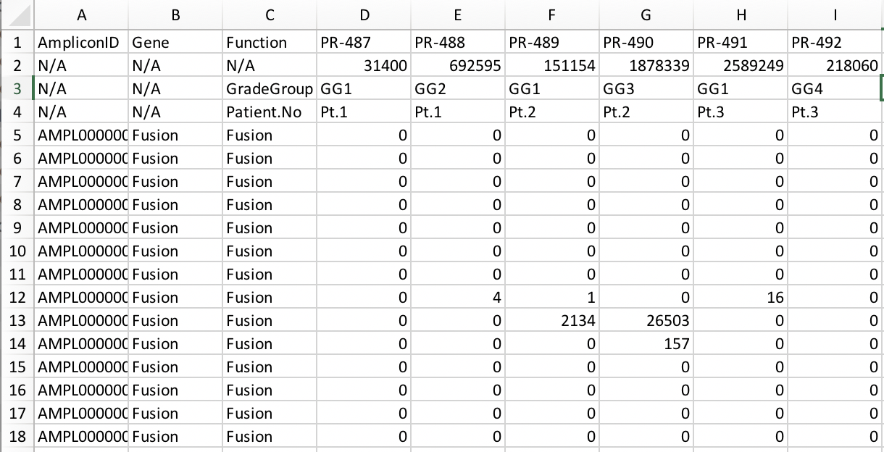

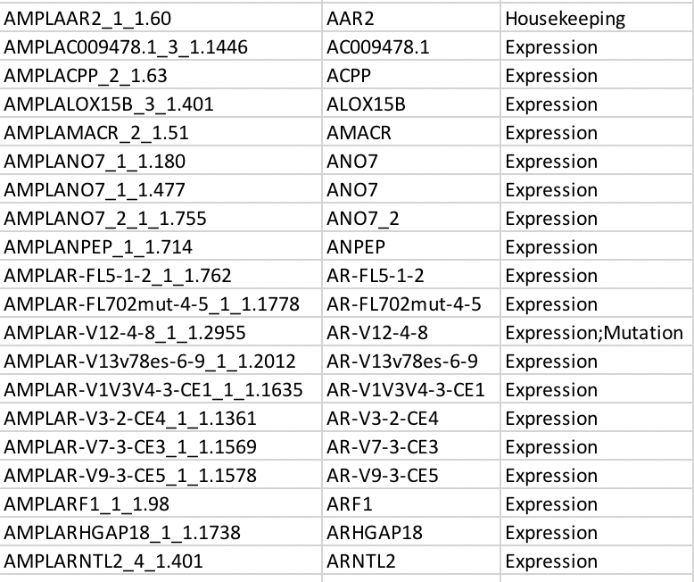

**Filtering:** Currently, samples with Total mapped reads **<500000** and **%e2e <60%** will be excluded from the analysis. Genes with absolute zero counts will also be excluded from the analysis. If you want to include all the genes change the cells with count value <10 to 10.